Test Case 8.1 POST login
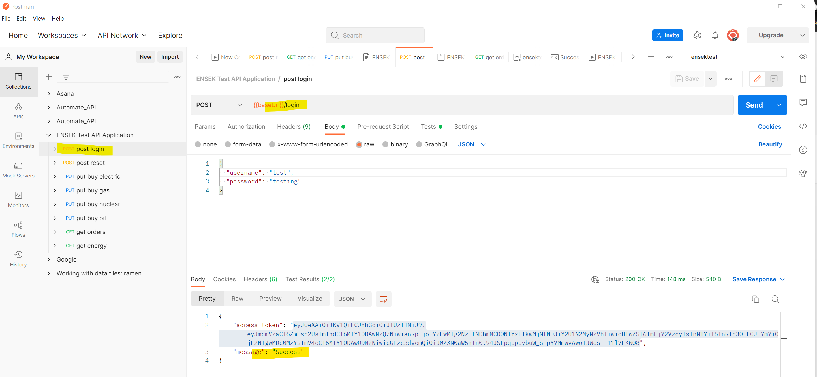
Login success

Test case 1. Reset the test data POST
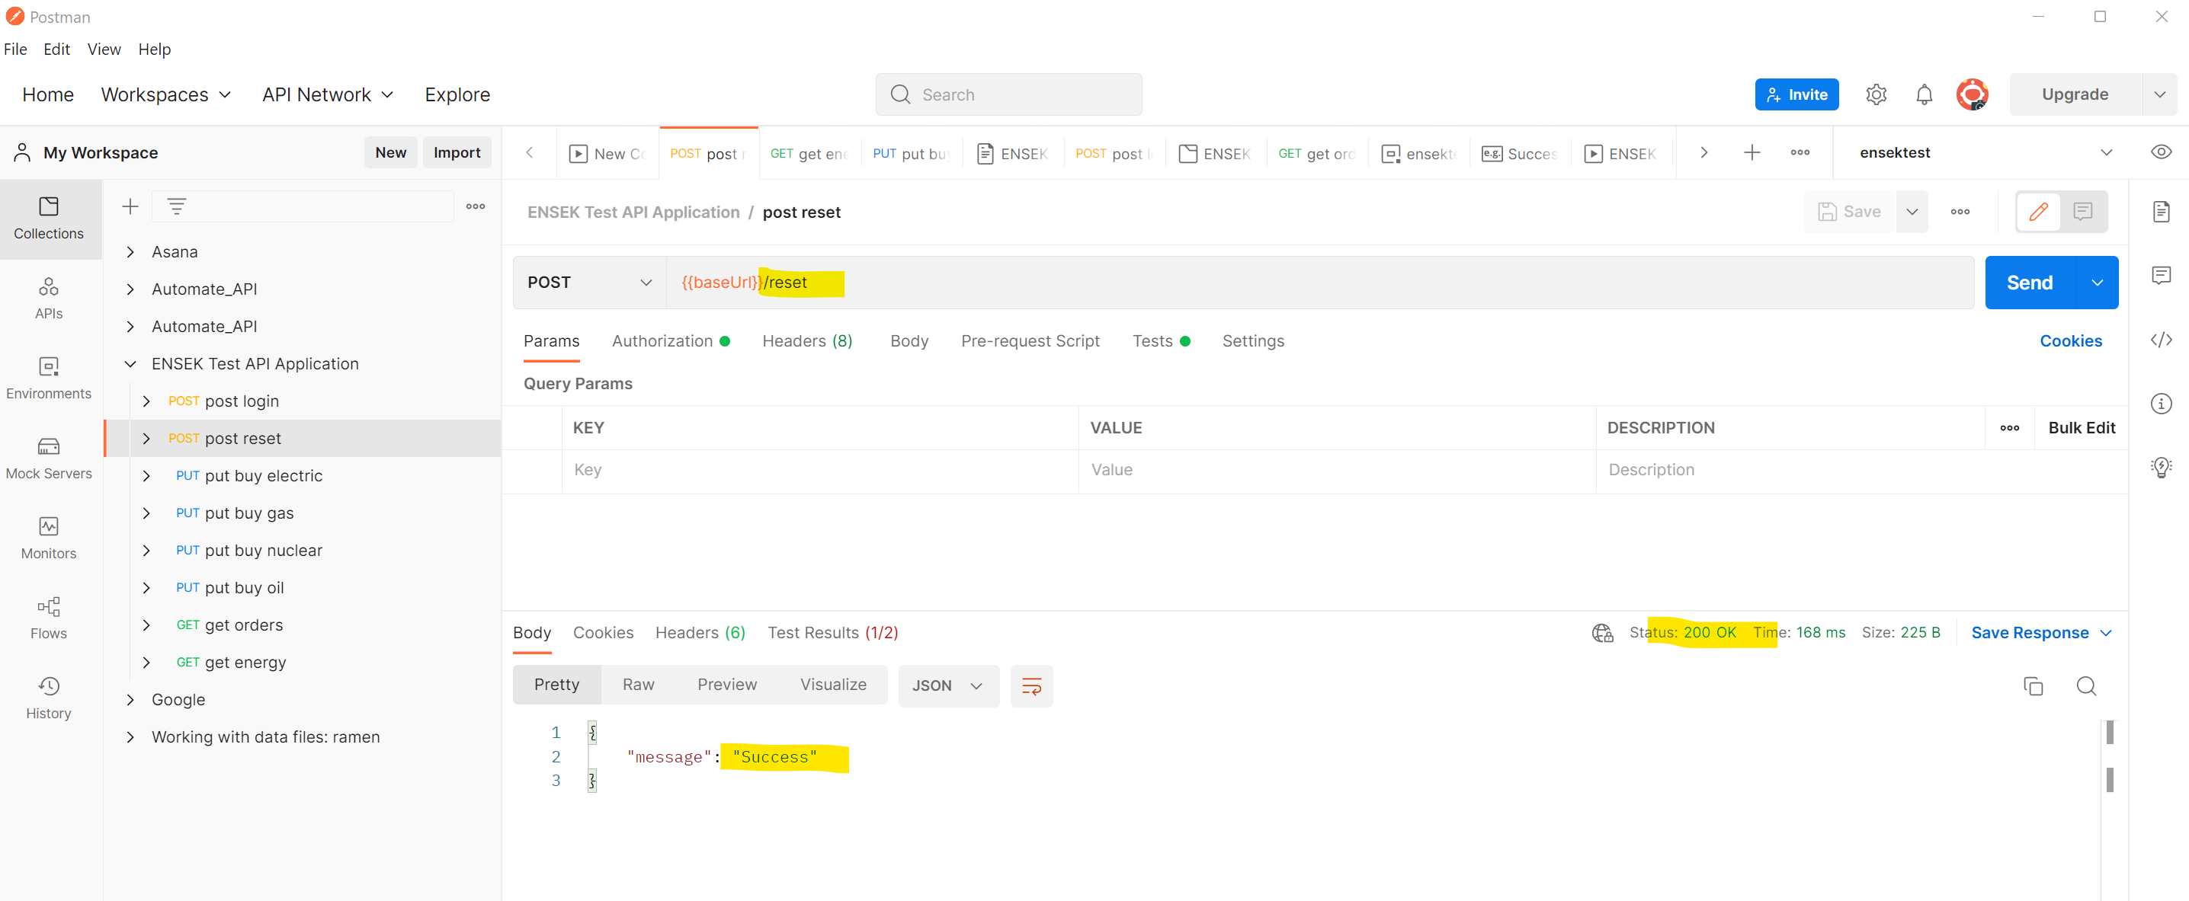

GET energy initial in stock
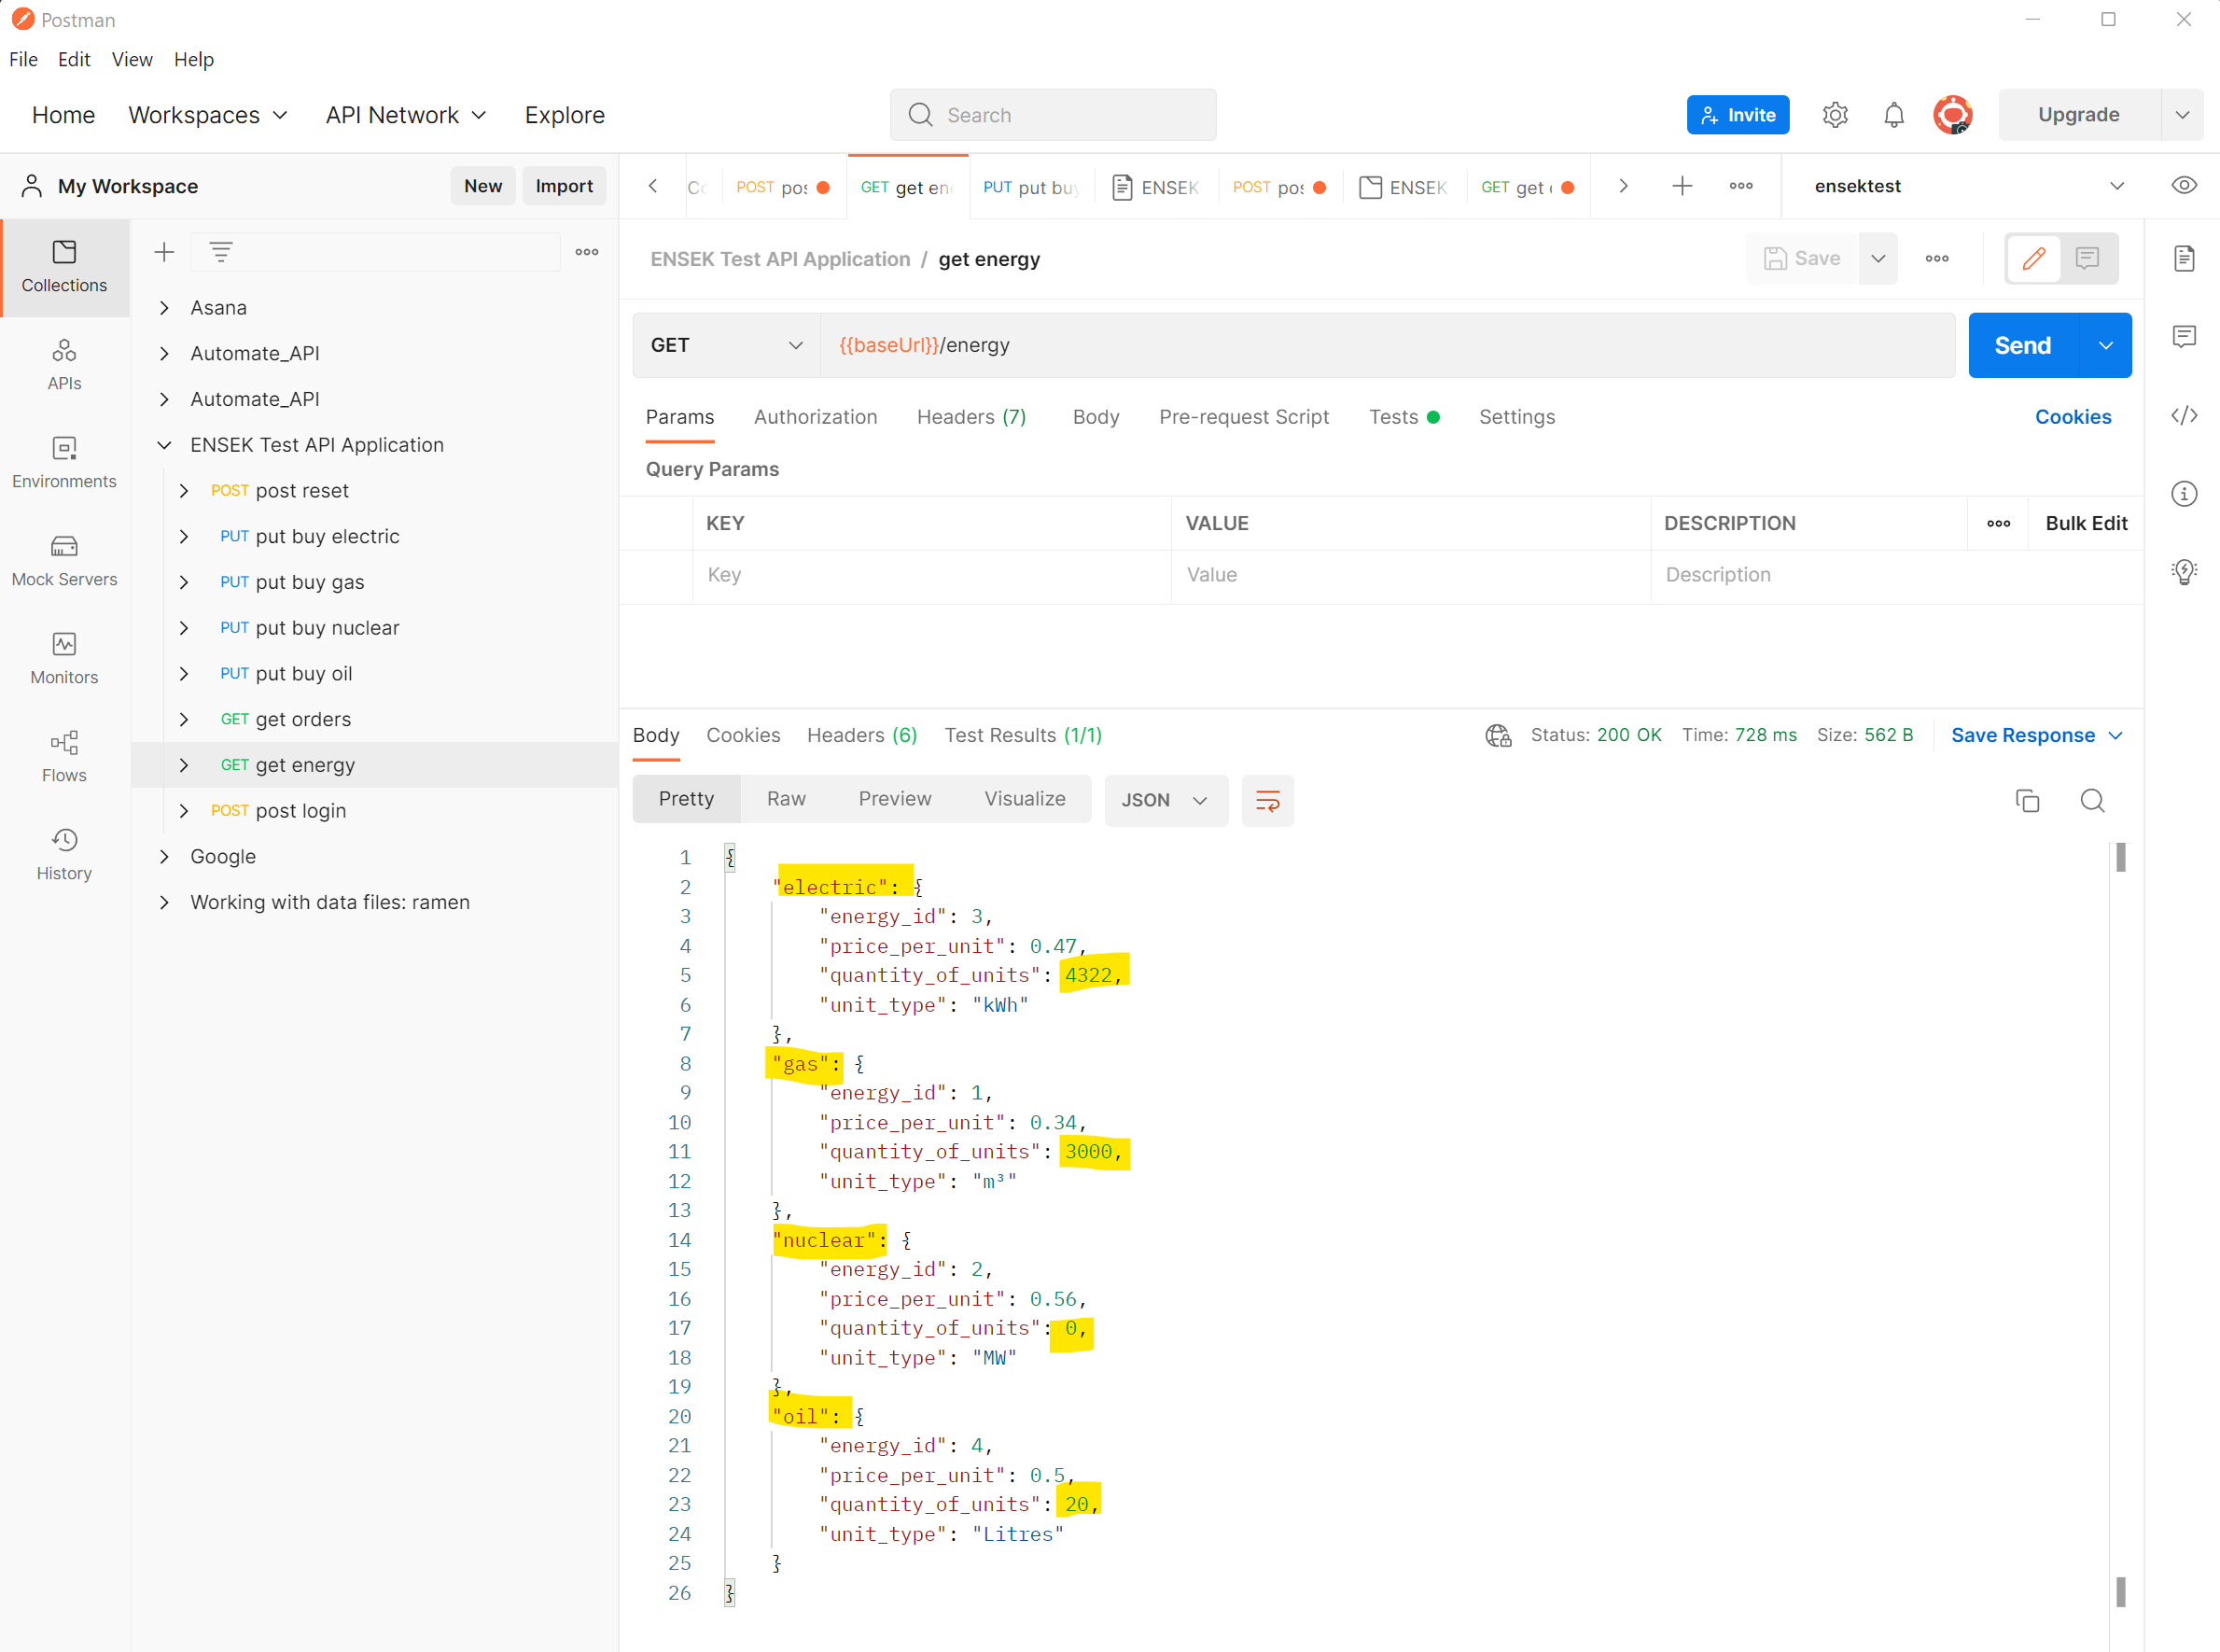

Electric quantity in stock = 4322
Gas quantity in stock = 3000
Nuclear quantity in stock = 0
Oil quantity in stock = 20

Test case 2.1 Buy a quantity of Electric within stock limit
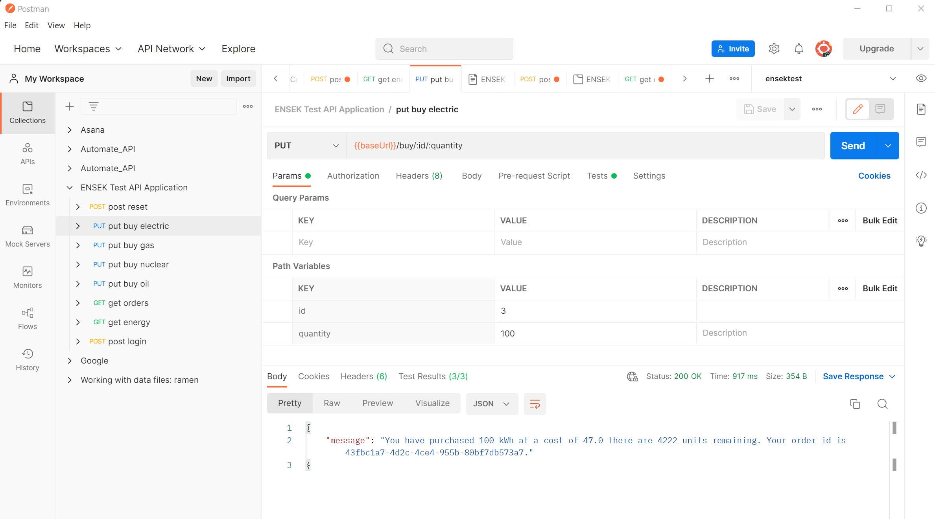
Electric quantity remaining should be 4222

Test case 3.1 Buy a quantity of Gas within stock limit
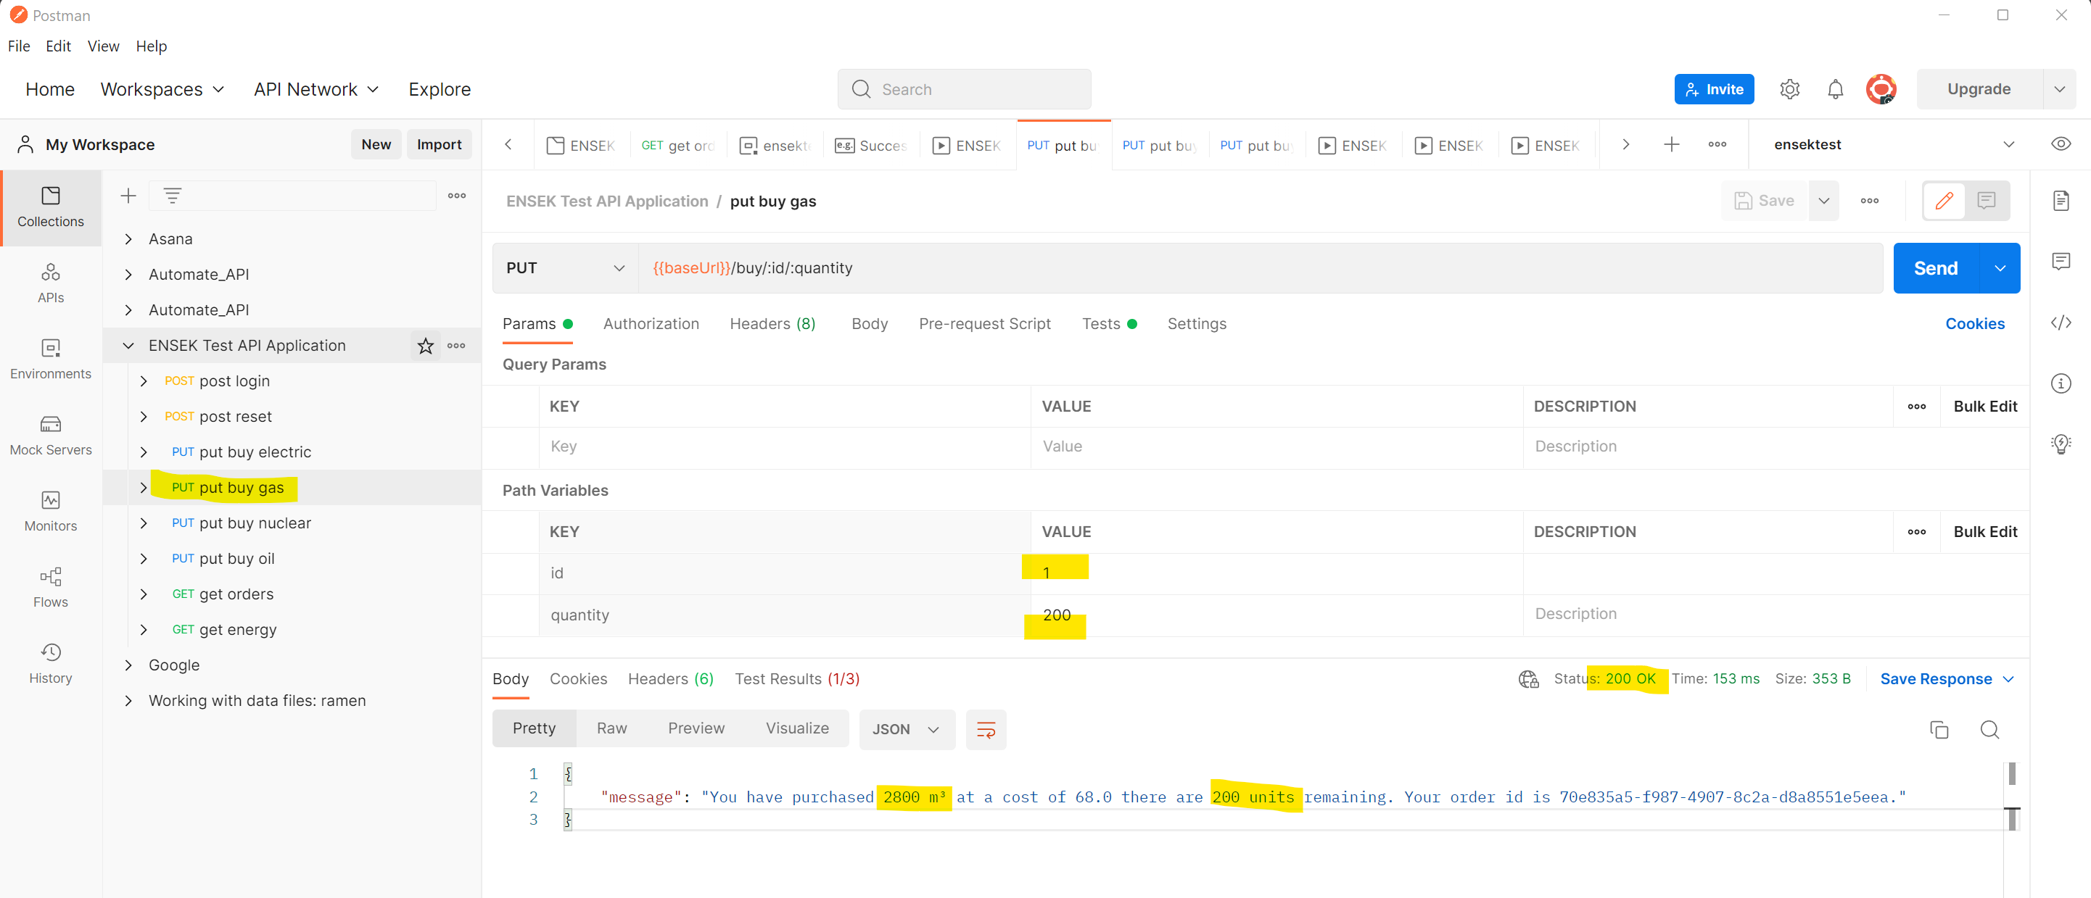

Quantity of Gas purchased is 200, remaining should be 3000-200 = 2800
Test failed as quantity purchased and units remainingnot as expected.

Test case 4.1 Buy a quantity of Nuclear within stock limit
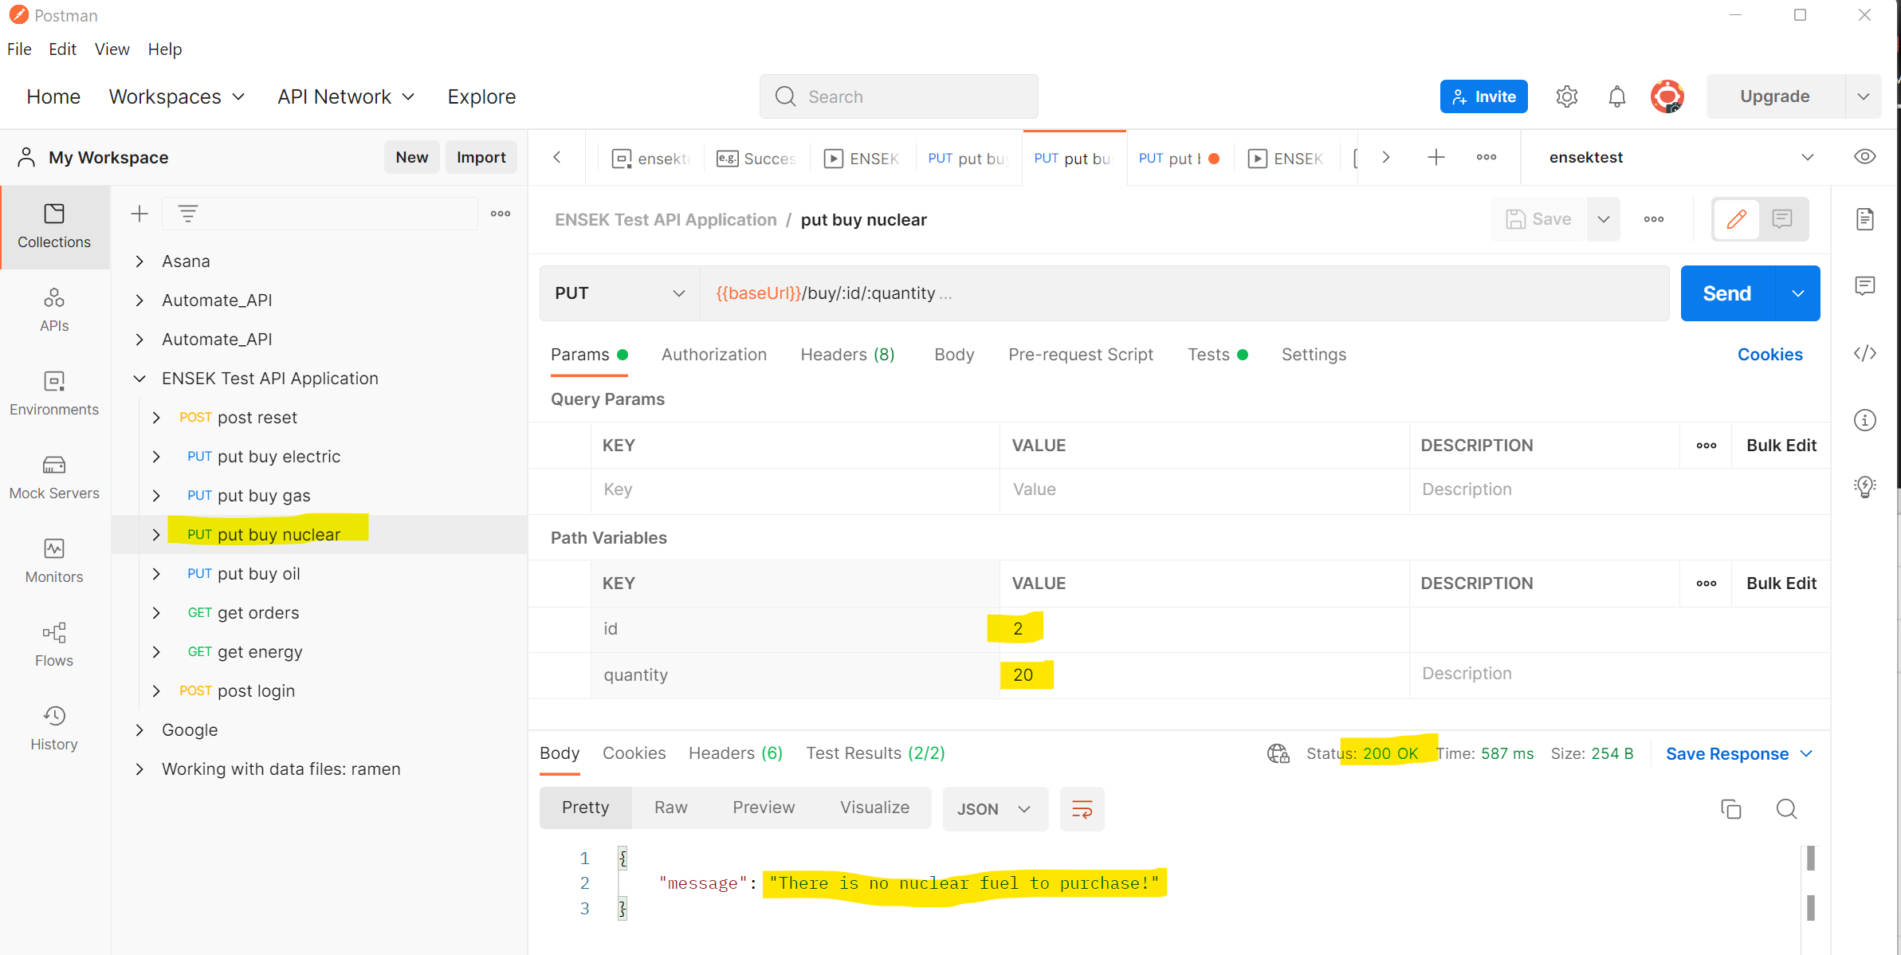
PASS as quantity of Nuclear in stock is zero

Test case 5.1 Buy a quantity of Oil within stock limit
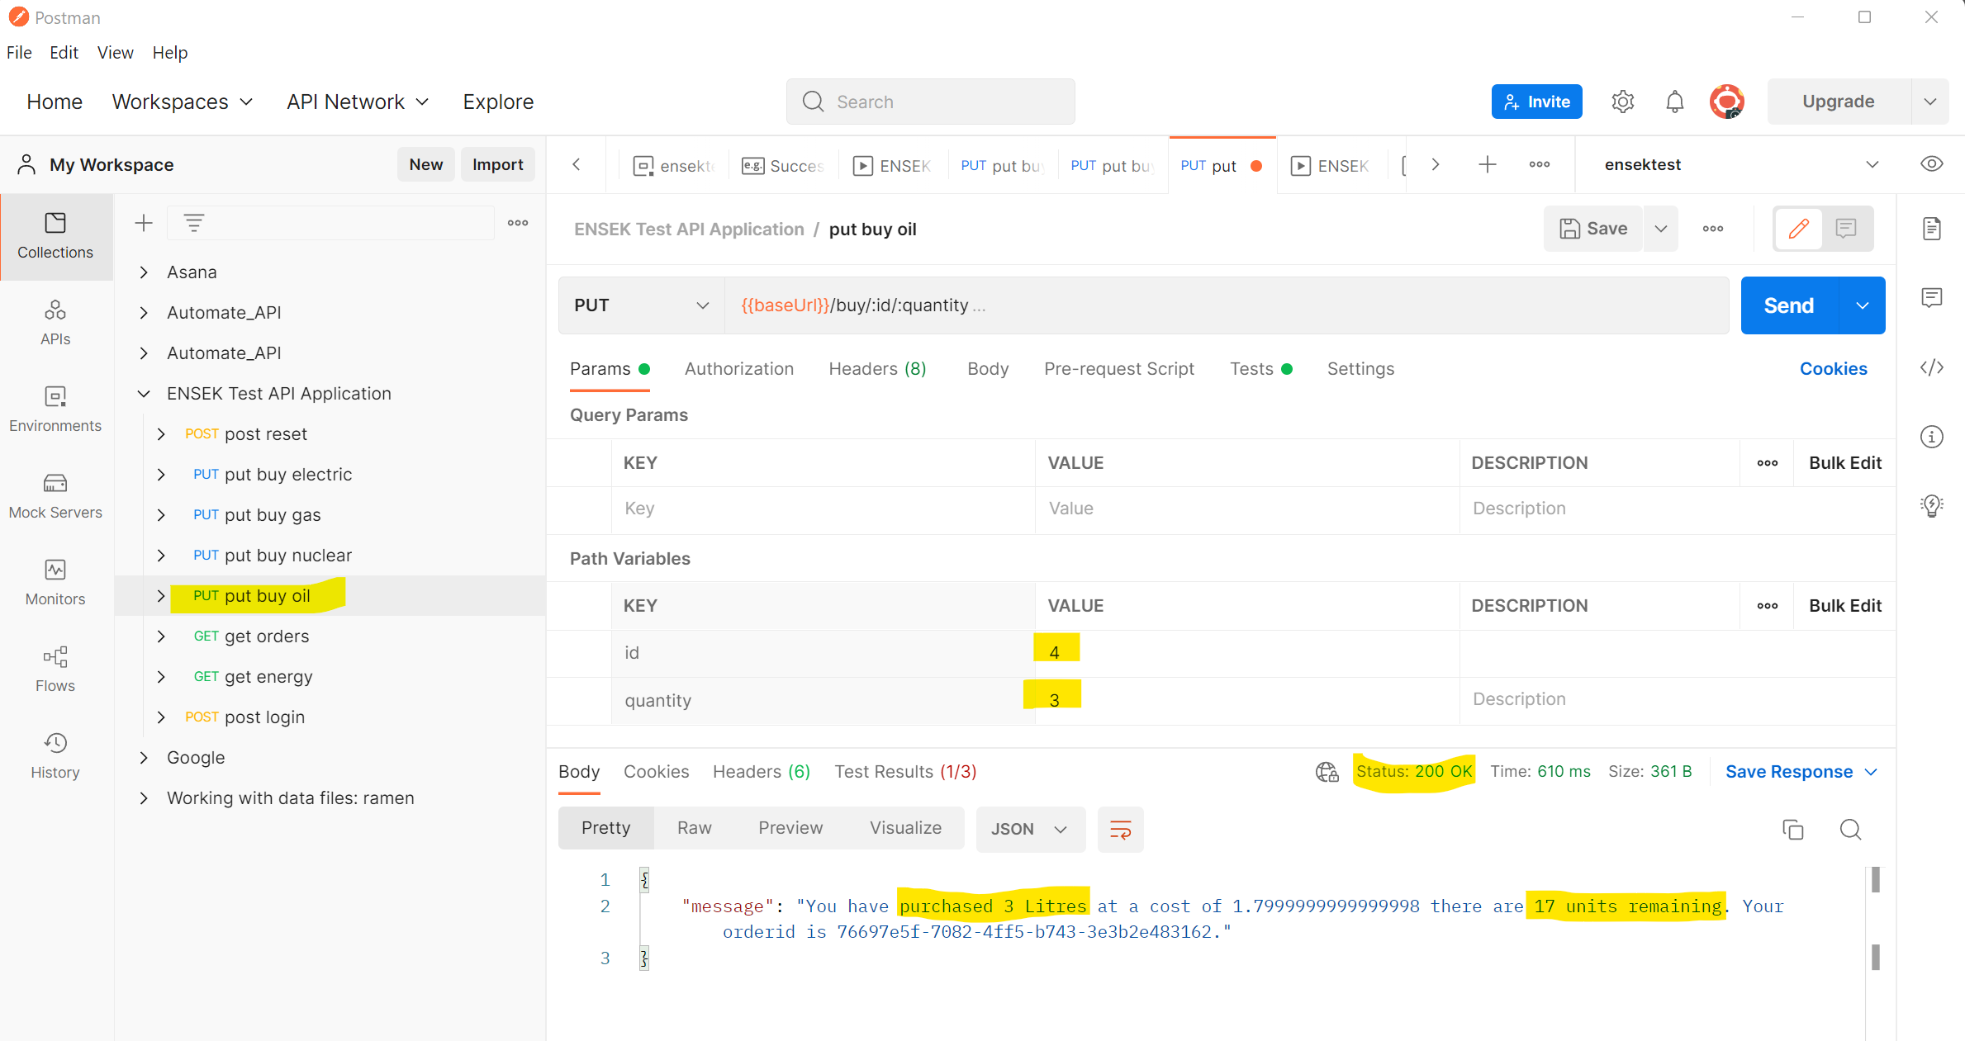
Purchased 3 litres out of 20, remaining should be 17 units. PASS
Cost should be 3 * 0.5 = 1.5 but returned 1.7999999998 not as expected. FAILED

GET all orders
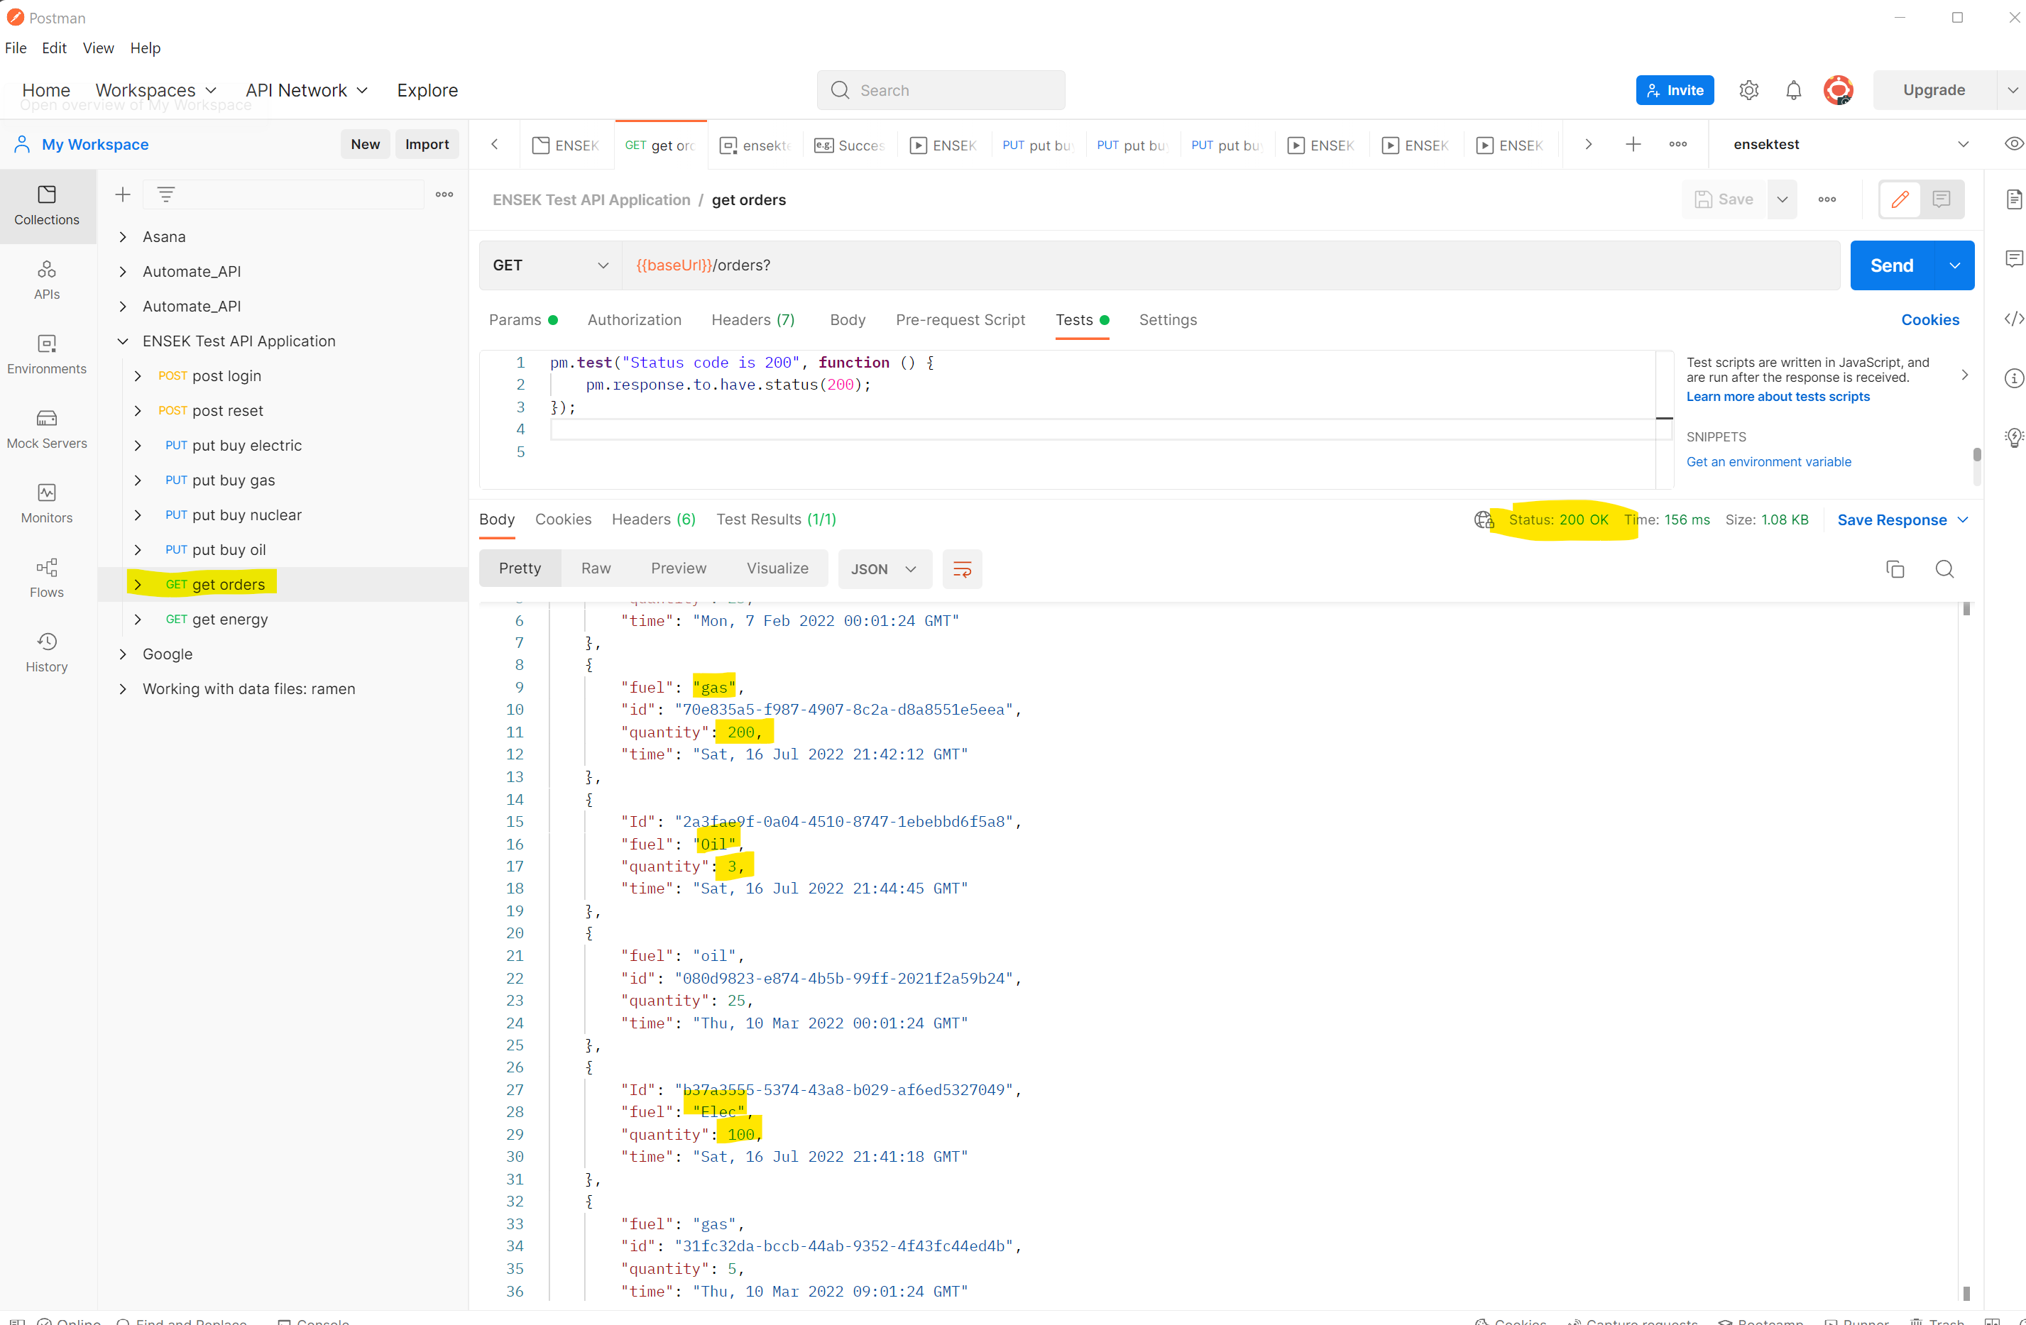

GET Energy after all purchases
